**SMART SURVEILLANCE**

**by**

**Tanmay Prakash -(Roll No:- 10800218007)**

**Manisha Kumari -(Roll No:-10800218055)**

**Kumari Simran -(Roll No:-10800218057)**

**Hardik Khanuja -(Roll No:-10800218065)**

**Project Report**

**Submitted to Asansol Engineering College in partial fulfilment of the requirements for the degree of**

**(Bachelor of Technology)**

**(Information Technology)**

**of**

**Maulana Abul Kalam Azad University of Technology**

**Under the guidance**

**Of**

**Dr. ANUP KUMAR MUKHOPADHYAY**

**(Assistant Professor)**

**(Head of Department(IT))**



**Department of Information Technology**

**Asansol Engineering College**

**Asansol**

**2022**

**CERTIFICATE FROM PROJECT GUIDE**

*This is to certify that the project entitled “****SMART SURVEILLANCE****” was submitted by “****Tanmay Prakash*** *(10800218007),* ***Manisha Kumari*** *(10800218055),* ***Kumari Simran*** *(10800218057),* ***Hardik Khanuja*** *(10800218065)”, for the award of B. Tech. (Information Technology) degree of West Bengal University of Technology is absolutely based upon his own work under the supervision* ***Dr. Anup kumar Mukhopadhyay****, Department of Information Technology, Asansol Engineering College, Asansol, India and that neither his project report nor any part of the report has been submitted for any degree/diploma or any other academic award anywhere before.*

*Name and Designation of Project Guide:*

***____________________________***

*Dr. Anup Kumar Mukhopadhyay*

*Assistant Professor,*

*(Head of Department)*

*Information Technology*

**Recommendation:**

**Recommended / Not Recommended**

**_______________ _______________ Internal Examiner External Examiner**

2

**ACKNOWLEDGEMENT**

We, the final year students of the 2018 batch of “**ASANSOL ENGINEERING COLLEGE**”, ” **Information Technology**” are presenting a project on “**SMART SURVEILLANCE**”. It was a great experience developing the project. It was a wonderful environment to work with all our group mates, their useful plans, suggestions and code contributions were highly appreciated.

We are thankful to Asansol Engineering College for providing us a scope to develop a project.

We are grateful to the project guide Lecturer Prof. **Dr. Anup Kumar Mukhopadhyay** for guiding us in this project. We get help in all possible ways whether it is theoretical or practical to successfully complete the project from our guide. They also tell us the importance of an application of the project. Without them our knowledge would not have flourished enough to complete the project.

**__________________**

**Tanmay Prakash**

**_________________**

**Manisha Kumari**

**_________________**

**Kumari Simran**

**_________________**

**Hardik Khanuja**

3

**CONTENTS**

**Chapters Pages**

1.Project Synopsis…………………………………………..5 2.Introduction………………………………………………7 3.ProjectDetails……………..…………………..………….10

3.1.System Requirements…….…...…….……………10

3.2.Definitions and Theories……...……….…….……..12

3.3. Outcomes of the Project………..….…………….21

4. Screenshots………………………………..………….…22

5. Conclusion and Future Scope………..……….…………...26

6. Bibliography……………………………………….………28

4

**Chapter - 1**

**Project Synopsis :**

This is a Python GUI application which can run on any system with python 3+ and has many features which are not in normal CCTV. This project uses pure python code and with the help of some python modules and some trained models. It analyses data from live video footage and it’ll do the smart surveillance for you. It’ll analyse the data and match it with different trained models to ensure that there is no potential threat in that vicinity. It can do several things like anti theft , motion detection, visitors counting, recognizing a person,finding parking space in a parking lot, weapon detection and obviously who can forget mask detection as it is becoming important these days for the safety of people.

*Project Objective:*

In this era of modernisation every street ,complex or apartment is fitted with CCTV (Closed Circuit Television) and recording lots of video footage each and every second, with every passing second there’s new data to analyse. Obviously people are required to analyse this data and do the surveillance, but with loads of data and hundreds of cameras being installed in every big complex and seeing various screens for hours can be a boring as well as a tough job and there is always a chance of some carelessness and human error as human’s average attention span is about 90 mins. So the idea is that there can be a program that can help our security officials to minimise their workload and make their work easy and less boring.

*Technologies Used:*

This project is purely based on Python and some of its modules, majorly OpenCV(Open-source Computer Vision). The GUI is made with the help of Tkinter (a python module used for making user interfaces). Its features also take help from some other modules named : numpy, tensorflow, pickle, cvzone, scikit-image, imutils and face_recognition.

Let’s Know some features/uses of the modules used in making it.

5

**TKinter :** This framework provides Python users with a simple way to create GUI elements using the widgets found in the Tk toolkit. Tk widgets can be used to construct buttons, menus, data fields, etc.

**Numpy :** NumPy is a basic level external library in Python used for complex mathematical operations. NumPy overcomes slower executions with the use of multi-dimensional array objects. It has built-in functions for manipulating arrays.

**Pickle :** Pickle in Python is primarily used in serialising and deserializing a Python object structure. In other words, it's the process of converting a Python object into a byte stream to store it in a file/database, maintain program state across sessions, or transport data over the network.

**cvzone :** This is a Computer vision package that makes it easy to run Image processing and AI functions. At the core it uses OpenCV and Mediapipe libraries.

**Scikit-image :** scikit-image (formerly scikits. image) is an open-source image processing library for the Python programming language. It includes algorithms for segmentation, geometric transformations, colour space manipulation, analysis, filtering, morphology, feature detection, and more.

**face_recognition :** Recognize and manipulate faces from Python or from the command line with the world’s simplest face recognition library.

Built using dlib’s state-of-the-art face recognition

built with deep learning.

6

**Chapter - 2**

**Introduction :**

In the present day and age, one can never be too careful. Security has become one of the most important factors governing everyday life. If you are working in an office, there are guards present 24/7, and the facility is also monitored by CCTV cameras. Even in your very own home, a security system is needed to prevent any kind of theft, robbery etc. With a security system in place it becomes easier to monitor the premises and also gather information of an incident. Security surveillance systems do not come cheap, and hundreds of dollars must be invested to make a surveillance system successful. You have to make sure a guard is there to monitor the system throughout the day. The cameras have to be placed at strategic locations, and for that a special team of surveillance experts is required. Now the question arises: what actually a surveillance system is ?

*What is a Surveillance System?*

A surveillance system is one that uses a combination of cameras and computer sensors to closely monitor specific locations. There are different levels of protection available, as well as several features that one can add to the system to customise it to specific needs. Generally, a surveillance system can be purchased through a security company, along with alarms and other additions. The main purpose of a surveillance system is to closely monitor a specific section or sections of a building or the outside of a building. They generally require one or more cameras to be installed in the areas being monitored. The cameras record everything that goes on and send the pictures to a screen set up in a separate location.

Each camera may have a separate screen, or they may share one screen which regularly switches from one scene to another.In many cases, a surveillance system features cameras that are attached to motion sensors. This means that if any movement is detected within the camera's range, the lens will move in the direction of the motion. By using motion sensors, it is not necessary for an intruder or prowler to walk into a particular area because the camera moves until he is in shot.There are also cameras that have lenses which adjust to low lighting. These are called night sensor lenses, and they can help catch things that normal lenses would miss during the nighttime hours.

Generally, they pick up body heat of anyone who enters the building.Many times, a surveillance system will be closely watched by a security guard or other watchmen. This way, multiple

7

cameras can be viewed at one time. If something out of the ordinary is noticed, there is often a separate security system that can be implemented. The watchman can either sound an alarm, turn on **motion sensor** lasers, or use some other system for letting the intruder know they have been spotted.Surveillance systems are most often used by stores where shoplifters may be a problem, or by large companies that have valuable goods or information on hand. Oftentimes they are reviewed after a crime has been committed to get a better look at the person or persons involved. This allows police to more effectively find criminals before they can commit additional crimes.

Prices for a quality surveillance system vary based on how many cameras are used, how many monitors are installed, and which features are added. The most high-tech systems can be quite pricey, but there are generally options available for almost any business's budget. Additionally, the price is justified with the peace of mind and potential savings in stolen goods.

The Advantages of Using CCTV Surveillance System The CCTV surveillance system has brought in a revolution in protecting homes and other commercial spaces. With their varied uses and countless benefits, you can see them in almost all places today. Few of CCTV camera benefits include:

• CCTV surveillance cameras provide enhanced security with utmost clarity and with ease of access.

• Anyone can handle the CCTV surveillance cameras with ease if they have access to them. • You can keep a track of production processes and other processes in industries and other production units.

• They are a must for every retail store, boutique, super markets and other shopping areas. • They prevent burglary by alarming you about the breach of security.

• The CCTV surveillance systems are not easily damaged by dust, and severe climatic conditions.

• During holidays they can be installed at your property thus they ensure the security of a home without making you worry anymore about your property when you are away.

• For people who employ a babysitter at home, this CCTV system gives you utmost satisfaction about your concerns about your younger one at home while looked after by a babysitter.

• You can connect the CCTV surveillance system to your mobile phone and without any computer or laptop you can easily access the live streaming of the recordings.

• At offices, the crucial situations like fire, burglary, and other security breaches can be easily recorded and can be used for future investigation purposes.

8

• Even governments make use of CCTV cameras to regulate traffic and also to check people’s disciplinary behaviours in public places.

• Even for leaving pets alone at home, installing a CCTV surveillance system will prove to be really helpful.

There are specialised designs and types of CCTV smart surveillance systems available in the market today. Based on the purposes for which they are used you can choose the best type of CCTV for your home or for your commercial space. For homes there are specific models available, for offices there are models with higher resolution available. You can visit a security **service provider company** for more details about choosing the best type of CCTV smart surveillance for your needs.

9

**Chapter - 3**

**Project Details :**

**3.1. System Requirements -**

This is a python GUI application which can run on any operating system. Requirements are mentioned below :

● *Software Requirements* **–**

○ Windows/Linux/Mac OS any version, as it is platform independent.

○ Python3, it needs python to be installed in our system to run this successfully. ○ Packages in python -

■ Opencv-python

■ Tkinter

■ Numpy

■ Tensorflow

■ Pickle

■ Cvzone

■ Scikit-image

■ Imutils

■ Face_recognition

*● Hardware Requirements –*

○ Working Desktop/Laptop

○ Webcam with drivers installed

*● Video Smart Surveillance System Design Requirements –*

This section provides the details of decisions taken while designing the video surveillance system. The following decisions are to be made for designing a video surveillance system:

**Camera and its type:** Cameras are the key contributors to the video surveillance system. The camera position and the type of cameras used under various conditions are important factors in video surveillance.

10

These two parameters are briefly explained below:

**Positions for camera installation-** Cameras should be placed in appropriate areas to record relevant video. The appropriate areas for proper placement of cameras can be entrances, hallways, driveways, T- Points, highway intersection points, exits, etc., and in areas where there is a high density of people or vehicles.

**Type of Camera to be used-** There are many types of camera available on the market. The suitability of the camera depends upon the situation in hand. Fixed camera can be used for recording only one specific view while a PTZ camera is generally used to cover wider fields of views. Other types of cameras that can be used are: **Box Camera**, **Dome Camera**, **IP Camera**, **Bullet Camera**, **Thermal Camera**, and more.

**Video Management System-** Video management system is the recording and management of access to the video, which is captured by a camera and is then transferred to the module of the video surveillance system. Videos can be transmitted over the computer network IP or they can be sent as analog videos. Videos from both IP cameras and analog cameras can be transferred over the computer network whereas unlike analog cameras, IP cameras can connect directly to an IP network. In case of analog cameras, an encoder must be installed to transmit analog video over IP.

**Types of Video Management System-** In a Video management system, videos taken by the cameras are stored, managed and are transmitted to various viewers. The video management systems usually used in video surveillance systems are: **DVR** (Digital Video Recorder), **HDVR** (Hybrid Digital Video Recorder), **NVR** (Network Video Recorder) and more.

**Storage Type-** In a video surveillance system, storage of the surveillance video is very vital. This video is used for later retrieval and review. Storage generally means magnetic disks, solid-state disks, and USB drives and may also refer to magnetic tapes and optical discs like CDs, DVDs, etc.Several techniques have been developed to optimise the use of storage because of its high cost. There are three main types of storage: **Hard drives**, **directly attached storage**, and **Capacity clusters**.

11

Types of Video Analytics- Video analytics encompasses the following tasks: **Storage optimization** and **Identifying threatening events**.

**Surveillance video display**- Videos captured by a surveillance system are eventually viewed by human beings and are usually used for past investigations. Videos can be viewed in 4 different ways: **Local**, **Remote**, **Mobile** and **Video**.

**3.2. Definitions and Theories -**

For this project we have used various latest technologies which will be evaluated in this part with every detail of why it is used. We’ll divide this section of the explanation of technology based on modules/features in the project.

But first let's see the language used in this project.

We have used Python language as it is very new and also comes with so many features like we can do Machine Learning, Computer Vision and Also make GUI applications with ease and it allows us to use a lot of libraries with ease.

Reasons for Selecting this language :

1. Short and Concise Language.

2. Easy to Learn and use.

3. Good Technical support over Internet

4. Many packages for different tasks.

5. Platform Independent.

Well these are just the minor points from our sides. Python is just a lot more than this. Python is a widely used general-purpose, high level programming language. It was created by Guido van Rossum in 1991 and further developed by the Python Software Foundation. It was designed with an emphasis on code readability, and its syntax allows programmers to express their concepts in fewer lines of code. Python is a programming language that lets you work quickly and integrate systems more efficiently.There are two major Python versions: Python 2 and Python 3.

12

Some specific features of Python are as follows:

1. An interpreted language. Contrary to C or Fortran, one does not compile Python code before executing it. In addition, Python can be used interactively: many Python interpreters are available, from which commands and scripts can be executed.

2. Free software released under an open-source licence: Python can be used and distributed free of charge, even for building commercial software.

3. Multi-platform: Python is available for all major operating systems, Windows, Linux/Unix, MacOS X, most likely your mobile phone OS, etc.

4. A very readable language with clear non-verbose syntax

5. A language for which a large variety of high-quality packages are available for various applications, from web frameworks to scientific computing.

6. A language very easy to interface with other languages, in particular C and C++. 7. Some other features of the language are illustrated just below. For example, Python is an object-oriented language, with dynamic typing.

Below are the different features which can be performed by using this project: ● Motion Detection

● Identification

● Parking Space (Empty space Detection)

● In Out (Entry and Exit of Person)

So let's see each feature one by one.

***● Monitor Feature :***

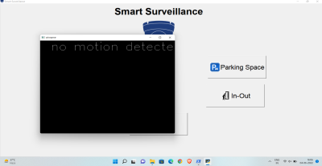

*Fig 3.2.1 : Monitor feature in Smart Surveillance System*

13

This feature is used to find what is stolen from the frame which is visible to the webcam. Meaning It constantly monitors the frames and checks which object or thing from the frame has been taken away by the thief.

This uses Structural Similarity to find the differences in the two frames. The two frames are captured first when noise did not happen and second when noise stopped happening in the frame.

SSIM is used as a metric to measure the similarity between two given images. As this technique has been around since 2004, a lot of material exists explaining the theory behind SSIM but very few resources go deep into the details, that too specifically for a gradient-based implementation as SSIM is often used as a loss function.

The Structural Similarity Index (SSIM) metric extracts 3 key *features* from an image: · Luminance

· Contrast

· Structure

*The comparison* between the two images is performed on the basis of these 3 features. 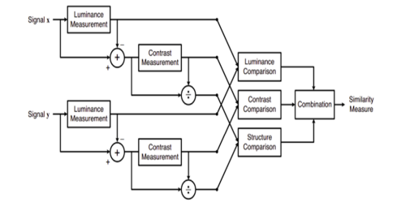

*Fig 3.2.2 : Flow chart for comparison of two images*

This system calculates the *Structural Similarity Index* between 2 given images which is a value between -1 and +1. *A value of +1* indicates that the 2 given images are very similar or the same while a *value of -1* indicates the 2 given images are very different. Often these values are adjusted to be in the range [0, 1], where the extremes hold the same meaning.

14

***● Identification feature :***

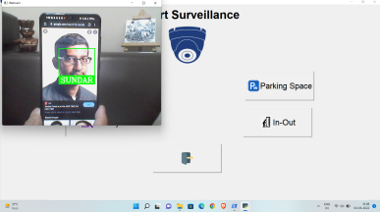

*Fig 3.2.3 : Identification in Smart Surveillance System*

This feature is a very useful feature of our minor project. It is used to find if the person in the frame is known or not.

It does this in two steps :

Find the faces in the frames

Use the LBPH face recognition algorithm to predict the person from an already trained model. So let's divide this into the following categories,

*Detecting faces in the frames:*

This is done via Haar Cascade classifiers which are again in-built in the openCV module of python.

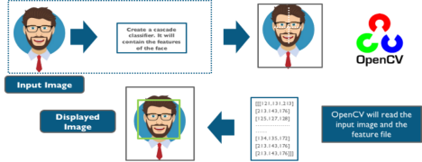

*Fig 3.2.4 : Haar Cascade Classifier overview*

15

Cascade classifier, or cascade *of boosted classifiers working with haar-like features*, is a special case of ensemble learning, called boosting. It typically relies on Adaboost classifiers (and other

models such as Real Adaboost, Gentle Adaboost or Logitboost).

Cascade classifiers are trained on a few hundred sample images of images that contain the object we want to detect, and other images that do not contain those images.There are some common features that we find on most common human faces :

· *a dark eye region compared to upper-cheeks*

· *a bright nose bridge region compared to the eyes*

· *some specific location of eyes, mouth, nose…*

The characteristics are called Haar Features. The feature extraction process will look like this : Haar features are similar to these convolution kernels which are used to detect the presence of that feature in the given image.

For doing all this stuff openCV module in python language has inbuilt function called cascadeclassifier which we have used in order to detect for faces in the frame 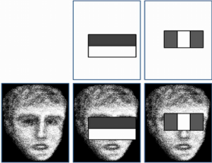

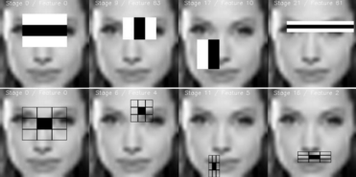

*Fig 3.2.5 : Cascadeclassifier for face detection*

16

*Using LBPH for face recognition:*

So now we have detected faces in the frame and this is the time to identify it and check if it is in the dataset which we’ve used to train our lbph model.

The LBPH uses 4 parameters:

1. Radius: the radius is used to build the circular local binary pattern and represents the radius around the central pixel. It is usually set to 1.

2. Neighbours: the number of sample points to build the circular local binary pattern. Keep in mind: the more sample points you include, the higher the computational cost. It is usually set to 8.

3. Grid X: the number of cells in the horizontal direction. The more cells, the finer the grid, the higher the dimensionality of the resulting feature vector. It is usually set to 8. 4. Grid Y: the number of cells in the vertical direction. The more cells, the finer the grid, the higher the dimensionality of the resulting feature vector. It is usually set to 8.

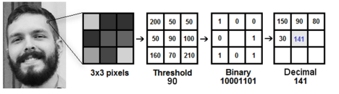

*Fig 3.2.6 : Sliding window in LBPH face detection algorithm*

The first computational step of the LBPH is to create an intermediate image that describes the original image in a better way, by highlighting the facial characteristics. To do so, the algorithm uses a concept of a sliding window, based on the parameters of the radius and neighbours. Which is shown perfectly via the above image.

17

Extracting the Histograms: Now, using the image generated in the last step, we can use the Grid X and Grid Y parameters to divide the image into multiple grids, as can be seen in the following image:

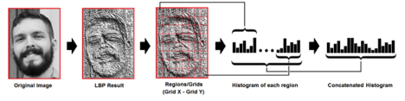

*Fig 3.2.7 : Extracting Histograms in LBPH face detection algorithm*

And after all this the model is trained and later on when we want to make predictions the same steps are applied to the make and its histograms are compared with the already trained model and in such a way this feature works.

***● Parking Space :***

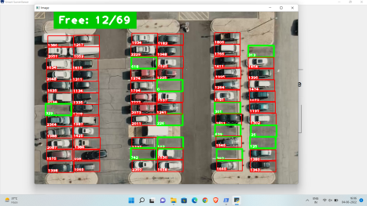

*Fig 3.2.8 : Parking Space in Smart Surveillance System*

18

This feature is efficient for finding vacant spaces for parking a car. In big complexes or malls there is always a problem of finding free space to park your vehicle. This feature uses basic image processing techniques to solve this problem and find a free space designated for parking. It works in a very simple way through mixing some techniques and ideas. As we know that CCTVs are fixed in their positions and don’t move, so it means the frame doesn’t change and thus we can pre-determine the position of the frame in which the car can be parked. As we know, cars can only be parked in designated spots. So, we came to the conclusion that we can save those particular spots in the frame in which the car can be parked, after the positions are determined we can store them in a file. And later that file can be used to determine those positions. After knowing those positions the program converts the image into grayscale and then converts into Gaussian blur and then after threshold ,median blur and dilation, those positions(in which the car can be parked) are checked for the number of non zero pixels. If any vehicle-like object is present in that frame then obviously this number should be high and thus that position will be above that threshold and that position will be marked as occupied. On the other hand if that position has not enough pixels then this number should be low and thus that position will be below that threshold and that position will be marked as not occupied. Thus a simple and effective way to find free spaces in a parking lot.

● ***Visitors in room detection(In-Out) :***

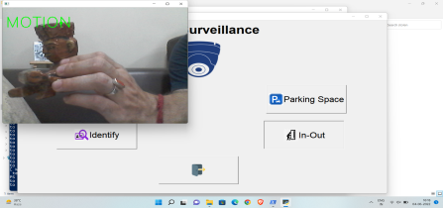

*Fig 3.2.9 : Motion detected- Inwards*

19

This is the feature which can detect if someone has entered the room or gone out. So it works using the following steps:

1 – It first detects noises in the frame.

2 – Then if any motion happens it finds from which side does that happen either left or right. 3 – Last check if motion from left ends to right then it will detect it as entered and capture the frame, or vise-versa.

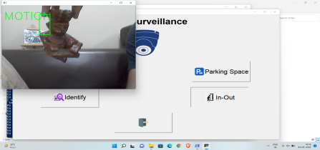

*Fig 3.2.10 : Motion detected- Outwards*

So there is no complex mathematics going on around this specific feature.

So basically to know from which side the motion happened we first detect motion and later on we draw a rectangle over noise and last step is we check the coordinates if those points lie on the left side then it is classified as left motion.

20

**3.3. Outcomes of the Project -**

There are many features and use cases of this project in this modern era where every corner of this world is rapidly covered with CCTVs and thus this video feed feeds can be better analysed with the help of some simple code. Although it may require human assistance at some point but as the technology advances there will be less and less human interference with every passing year. Let's discuss some of its features in detail.

1. Monitor : It basically analyses the data for any change of frames and can be better for detecting the stolen/missing items in the frame. Its use case can be understood by an example. Let's say there’s a museum and obviously it's a crowded place with many items on display so this feature will come in handy while the camera will be set on those precious artefacts and if any items goes missing it can be detected.

2. In-Out : It keeps a record of persons/vehicles/objects going in and out from a gateway/passage/room. For example if there is a place with staff only access then this program will keep a record of the people going in and out of the particular area and it'll also keep a snapshot of the person so that we don’t have to check the entire footage for this particular thing.

3. Parking Space : This feature requires a bird eye view of the parking space. It’ll keep a count on the cars parked there in the designated parking space and tell the empty parking space.

4. Identify : It identifies a person’s face by matching it with the photos present in its database and also stores the attendance of the person with the timestamp. It can also be used for attendance purposes and identifying known persons and keeping a record of their entry.

21

**Chapter - 4**

**Screenshots :**

**4.1. Main screen GUI :-** It shows all the icons present in the main screen. 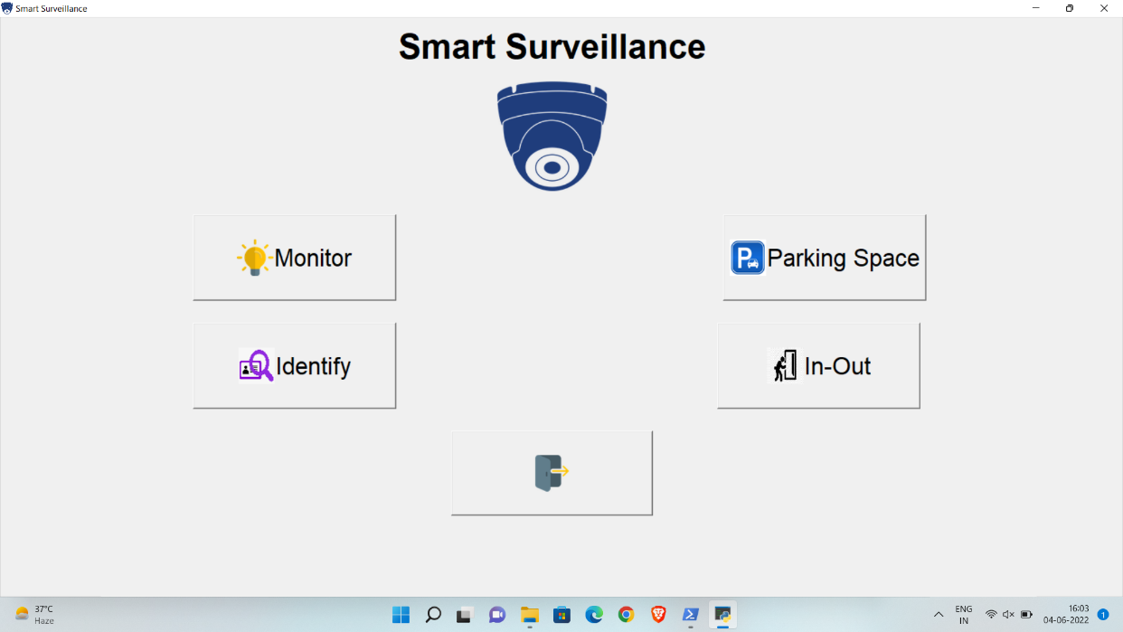

*Fig 4.1.1 : Main GUI Screen*

**4.2. Identify :-** This feature identifies the person but data is required(picture of the person should be uploaded first).



*Fig 4.2.1 : Identify Screen*

22

**4.3. Monitor :-** It detects any change in the frame and is used for detecting stolen items in the frame and also stores the snapshot when any movement is detected.



*Fig 4.3.1 : Monitor Screen*

**4.4. Parking Space Detector :-** It detects the empty space and helps in counting parking space. 

*Fig 4.4.1 :- Parking Space Screen*

23

**4.5. In Out :** - Finds who entered and left the room.

*Fig 4.5.1 : In-Out Screen*



*Fig 4.5.2 : Snapshot taken of the Object/Person entering the premises*

24



*Fig 4.5.3 : Snapshot taken of the Object/Person leaving the premises*

25

**Chapter - 5**

**Conclusion and Future Scope -**

***5.1. Future Scope :***

Installation of CCTV cameras helps not only to prevent crimes due to visual control but also to charge criminals using the information recorded by video cameras. Video surveillance systems installed in manufacturing departments or warehouses repeatedly proved its efficiency and cost recovery owing to significant reduction of risks. If we install a video surveillance system, we will be able to:

● monitor every stage of the manufacturing process;

● prevent quality failure, violation of working conditions, safety rules;

● have full and recorded data about production accidents;

● prevent thefts and damage of manufactured goods and products as well as manufacturing equipment.

CCTV also allows remote control from video cameras through the Internet on any personal device (tablet, smart phone, desktop).

Places Where Video Surveillance Is Required:

Factories, plants and other industrial enterprises

Video surveillance in manufacturing departments

Banks, office centres, business centres

Shopping malls, logistics centres

Outdoor facilities, building sites, warehouses, elevators

Passenger stations, railway stations, transport

Apartments, houses, offices, country houses.

Integration of Video Surveillance with Other Security Systems:

Complex integrated security system may consist of:

Video surveillance system.

Access control system, which enables to keep a record of staff working hours, receive information about the zonal location of employees.

System of automatic recognition of car licence plates at the entrance or on parking lots, which gives visitors statistics, grants access to parking lots by permits.

Security alarm system, fire alarm system, fire fighting system. Security functions are performed in the most efficient way with the help of motion detectors on video cameras and intrusion

26

detection sensors. When an undesirable event happens in a certain area, the operator is immediately informed by the system.

Integrated security systems can be built on the territory of distant objects but have a common control centre.

***5.2. Conclusion :***

The principal points of the Advance Intelligent video surveillance system (AIVSS) are to build up an observation system which can function as an indoor/open-air observation system. The Advanced Intelligent Video Surveillance System has a more extensive degree to take a shot at. As nowadays security and protection assume an essential part of the survival of the individual. The perfect observation engineering will have the accompanying attributes: eliteness, adaptability, simple upgradability, low advancement cost, and a way to bring down cost as the application develops and volume inclines.

At present, the video surveillance industry utilises simple CCTV cameras and interfaces as the premise of observation systems. These system parts are not effortlessly expandable and have low video determination with practically zero flag preparation. Nonetheless, the up and coming age of video surveillance systems will supplant these segments with more current computerised LAN cameras, complex picture handling, and video-over-IP steering. They will never again be essentially surveillance camera systems in addition to video correspondence systems.

27

**Chapter - 6**

**Bibliography -**

● Libraries Installation Process: **https://docs.python.org/3/installing/index.html**

● Learning guide and planning**: https://www.computervision.zone/**

● Guide to OpenCV: **https://opencv.org/**

● Guide to Tkinter: **https://docs.python.org/3/library/tkinter.html**

● Working for a face recognition system: **https://face-recognition.readthedocs.io/en/latest/readme.html**

28